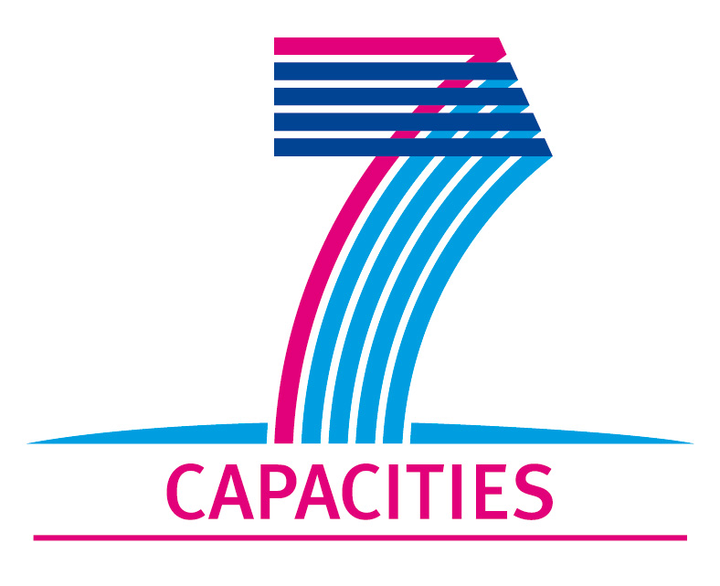

Research for the Benefit of SMEs
FP7-SME-2013
BAKE4FUN
Innovative biotechnological solutions
for the production of new bakery functional foods

Grant Agreement Number 606476

BAKE4FUN KICK-OFF MEETING
DATE AND VENUE
November 6th - 7th, 2013
Alma Mater Studiorum – University of Bologna
Via Zamboni, 33 – Bologna
Bologna (Italy)

FINAL AGENDA

Objectives of the meeting
- BAKE4FUN overview: objectives and structure
- Presentation of the BAKE4FUN Partners
- Administrative and management issues
- Discussion on incoming activities
- Dissemination activities

Wednesday, November 6th 2013
14.30-14.15: Arrivals and registration
14.30-14.40: Welcome to Participants
14.40-15.30: Presentation of project objectives, rationale, concept and connections among WPs (Andrea Gianotti)
15.30-15.45: Deliverables and milestones in the first 12 months
(Andrea Gianotti/Simone Maccaferri/Monica Forni)
15.45-16.20: Presentation of project partners: current activities and involvement in BAKE4FUN (5 minutes each)
16.20-16.40: Break
16.40-18.30: Presentation of WP activities (WP leaders)
16.40-17.00 WP2: Optimization of ingredient formulations and processes solutions (TUL – Malgorzata Bryszewka)
17.00-17.25 WP3: In vitro evaluation of the peculiar functional characteristics of FFB and AFB (AINIA)
17.25-17.50 WP4: Iron bioavailability and functionality effects of the selected products in pig animal model (UNIBO -Monica Forni)
17.50-18.10 WP5: Formulation and production of functional bakery foods (EPSA – Maria Del Mar Sanchez )
18.10-18.30 WP6: Exploitation and Dissemination (INDESPAN –Maria Luisa Llin Albiñana )
18.30 End of 1st day

20.00 Dinner at the Restaurant “Bottega di Franco”
Via Agucchi, 112 - 40131 Bologna
Tel. +39 051 311243

Thursday, November 7th 2013
09.00-10.10: Project Management-Administrative and financial issues (Alessandra Baccigotti)
10.10-10.25: Break
10.25-11.30: Action plan. Some suggested crucial points to discuss (not exhaustive) for the next 12 months. Chaired by Andrea Gianotti (10 min each WP leader).
10.25-10.35 WP2: Interactions between SMEs and RTDs to plan ingredients and final food sample shipping (time, amount, lots traceability, storage of raw material etc.) (TUL – Malgorzata Bryszewka)
10.35-10.45 WP3: Interactions between SMEs and RTDs to define Amount/Timing requirements of ingredients and experimental breads for in vitro studies
10.45-10.55 WP4: Amount/Timing requirements of experimental breads for in vivo studies (UNIBO -Monica Forni)
10.55-11.05 WP5: Formulation and production of functional bakery foods (EPSA – Maria Del Mar Sanchez )
11.05-11.30 WP6: Web, media, congresses at national/ international level. Institutions to be contacted (EFSA, FAO, …) (INDESPAN – Maria Luisa Llin Albiñana)
11.30-12.00: General discussion, questions and doubts to be solved
12.00-12.15: Closing remarks, summary of scheduled activities and planning of next meeting (Andrea Gianotti)
12.15 End of the meeting
For the Partners who will stay longer, UNIBO will suggest a restaurant nearby to have lunch together

